1.

ONE LINE TO be the place holder for other HTML FILE .  
id “main-content” used to point other html from js file.



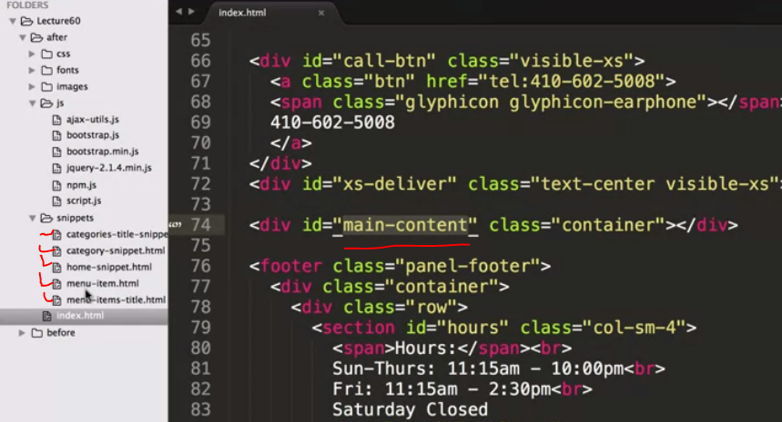

2. now in buttons: instead of setting links we need to set onClick methods to call a particular function of js file.  
inside that function we need to place the url of the html file we needed.

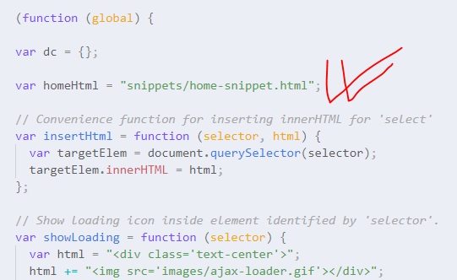

3. now to insert HTML:

Code:

//*Convenience function for inserting innerHTML for 'select'*

var insertHtml = function (selector, html) {

  var targetElem = document**.**querySelector(selector);

  targetElem**.**innerHTML = html;

};

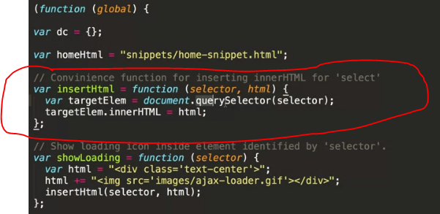

4.ajax lodin icon : <http://www.ajaxload.info/>